Java AWT Tutorial
Java AWT (Abstract Window Toolkit) is an API to develop GUI or window-based applications in java.Java AWT components are platform-dependent i.e. components are displayed according to the view of operating system. AWT is heavyweight i.e. its components are using the resources of OS.The java.awt package provides classes for AWT api such as TextField, Label, TextArea, RadioButton, CheckBox, Choice, List etc.
Hierarchy of AWT

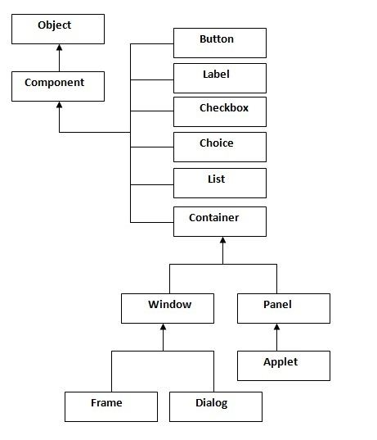

Container
The Container is a component in AWT that can contain another components like buttons, textfields, labels etc. The classes that extends Container class are known as container such as Frame, Dialog and Panel.

Window
The window is the container that have no borders and menu bars. You must use frame, dialog or another window for creating a window.

Panel
The Panel is the container that doesn't contain title bar and menu bars. It can have other components like button, textfield etc.

Frame
The Frame is the container that contain title bar and can have menu bars. It can have other components like button, textfield etc.

Java AWT Example

To create simple awt example, you need a frame. There are two ways to create a frame in AWT.

1)By extending Frame class (inheritance)
2)By creating the object of Frame class

AWT Example by Inheritance

import java.awt.*;
class First extends Frame{
First(){
Button b=new Button("JAVA");
b.setBounds(30,100,80,30);// setting button position
add(b);//adding button into frame
setSize(300,300);//frame size 300 width and 300 height
setLayout(null);//no layout manager
setVisible(true);//now frame will be visible, by default not visible
}
public static void main(String args[]){
First f=new First();
}}

AWT Example by Association

import java.awt.*;
class First2{
First2(){
Frame f=new Frame();
Button b=new Button("click me");
b.setBounds(30,50,80,30);
f.add(b);
f.setSize(300,300);
f.setLayout(null);
f.setVisible(true);
}
public static void main(String args[]){
First2 f=new First2();
}}

